GETTING STARTED WITH WORDPRESS

Congratulations on your new web site!

Your site has been built on the WordPress platform. WordPress is a user-friendly, yet powerful, Content Management System. Originally built as a blogging platform, its expansions through the years provide increased functionality for a wide range of web sites. It is a stable system with minimal issues. It’s also extendible with plugins available through the WordPress community. Go ahead; ask us if we recommend any for your particular needs.

Since WordPress is so well established, there are plenty of resources available online and in your local bookstore. If you need additional help, try a search for WordPress!

LOGIN

In your web browser of choice, go to the following address:
http://www.your-site.org/wp-admin

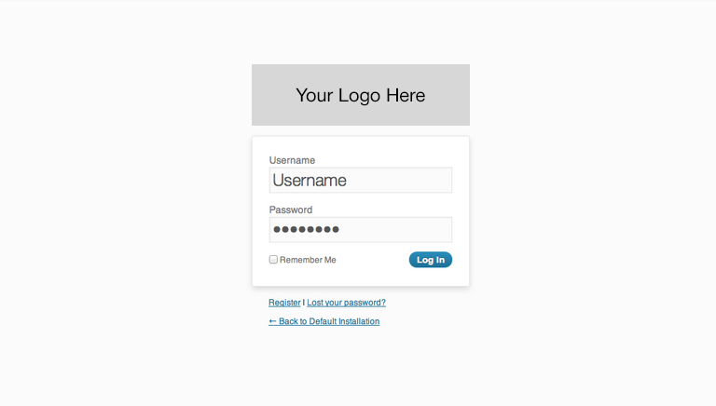

When your account was added, you should have received an email from the system including your login credentials. If you haven’t received a welcome email, please let your client contact know. Record your credentials here for future reference:

Username:
Password:
Enter this information on the login screen. Select “Remember Me” if you are on a computer that isn’t shared with other users.

Click “Log In”
Forgot your username or password? Click “Lost your password?” and retrieve it using the email address associated with your account. DO NOT keep typing in password guesses as it will lock you out of the system (it could also lead to your IP being blocked, which can block your entire organization).

DASHBOARD

The Dashboard is your site’s administrative area at a glance. Some additional information may show up here if plugins that take advantage of this feature are installed. This page shows an overview of Posts, Pages, and Comments. You can customize this screen by clicking “Screen Options” and unchecking or checking what you’d like to appear. You can also drag and drop modules anywhere. All changes are account-specific, so it will not affect any of your coworkers.

If at any time you find that you need additional help, you may access the WordPress codex by clicking “Help” in the top right corner. Typically, this will give you contextually relevant help for the section you are in.

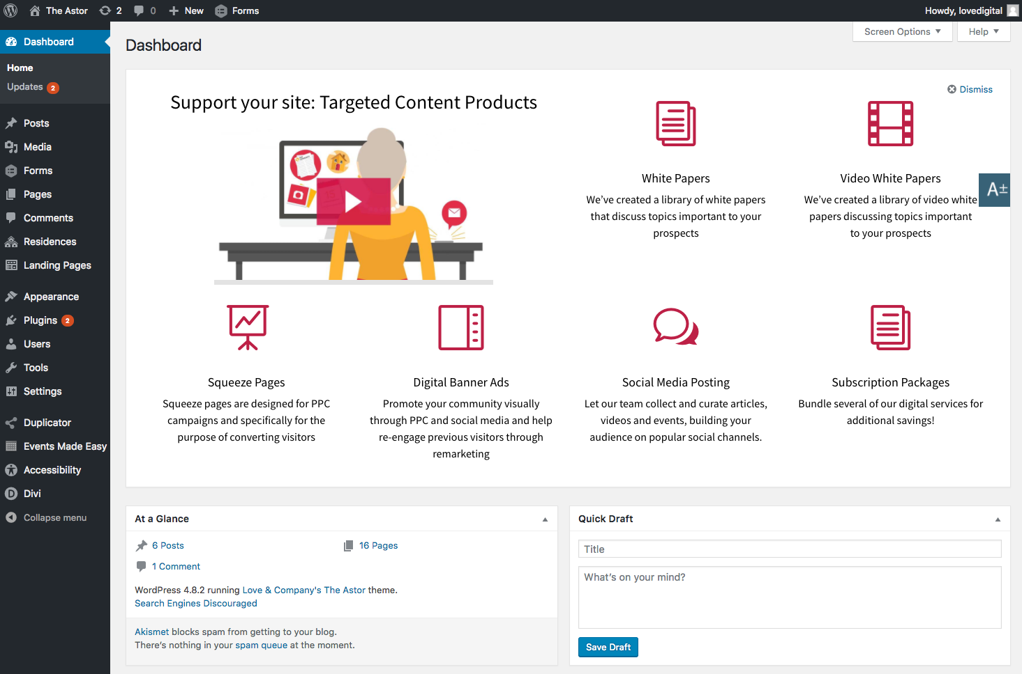

On the left hand side, you’ll find the navigation to all pages of your site’s back end system. From here you’ll be able to access every part of your site. Hovering over an item will open a submenu, while clicking takes you to the overview or listing page, and opens the submenu beneath the item you clicked.

YOUR PROFILE

First things first, let’s do some housekeeping on your personal profile. Hover over your name in the top right corner and select “Edit My Profile” from the drop down menu that appears.

You may also access this area by clicking or hovering over “Users” in the left menu, and selecting “Your Profile” from the options under that.

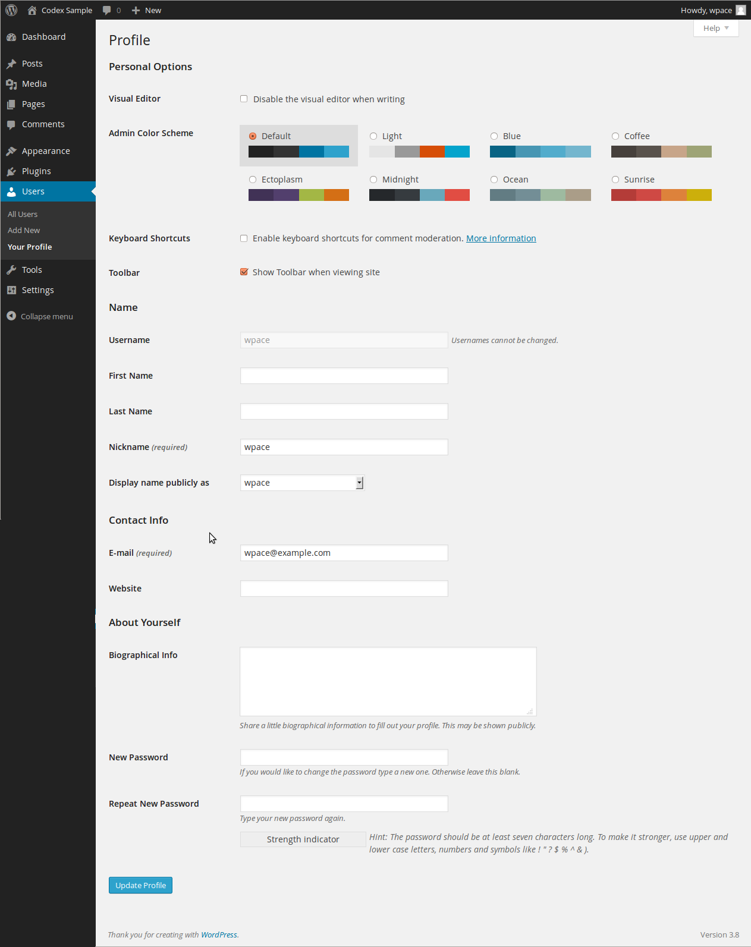

From this page, you can change all of your settings, including the colors that you would prefer to see the administrative area displayed in. Your color settings are unique to your account, so you can change the colors without fear that it will affect other users within your organization.

Leaving the toolbar option checked will display an admin toolbar at the top of your web site when you are logged in to the back end of the site. This may affect how some things on your site display, so if you leave this setting turned on, don’t worry if something is not rendering properly.

From the “Display name publicly as” drop down menu, you can select how your name is displayed on blog posts. We recommend changing this to something other than your username to help with security (your display name is available on the authors page of your WordPress website, so if you have it set to your username, that is one less step hackers need to take to get access to your backend) If you are adding articles to the News/Blog section of your web site, then you will want to change it to something that makes sense to readers. You can utilize the “Nickname” field to force it to display something other than your name, for example, if you’d like it to display the community name instead. Once you’ve typed something in the “Nickname” field, it will display as an option in the “Display name publicly as” dropdown menu.

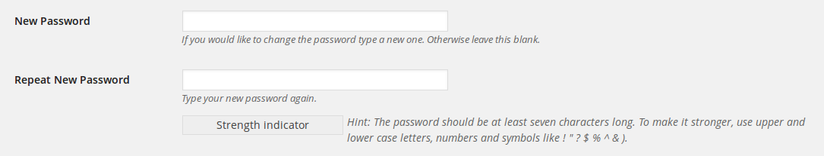

At the bottom of the Profile page, you will find the fields to change your password. Try to choose something that is secure and makes the “Strength Indicator” turn green. Feel free to let WordPress’ built-in secure password generator create a strong password for you – just be sure to write it down somewhere so you remember it!

When you have changed all desired settings, click “Update Profile”.

USERS – ADD NEW

If you want to add another person from your organization to share the ability to make changes to your site, you may add a user.

Under the “Users” menu on the left, click “Add New”.

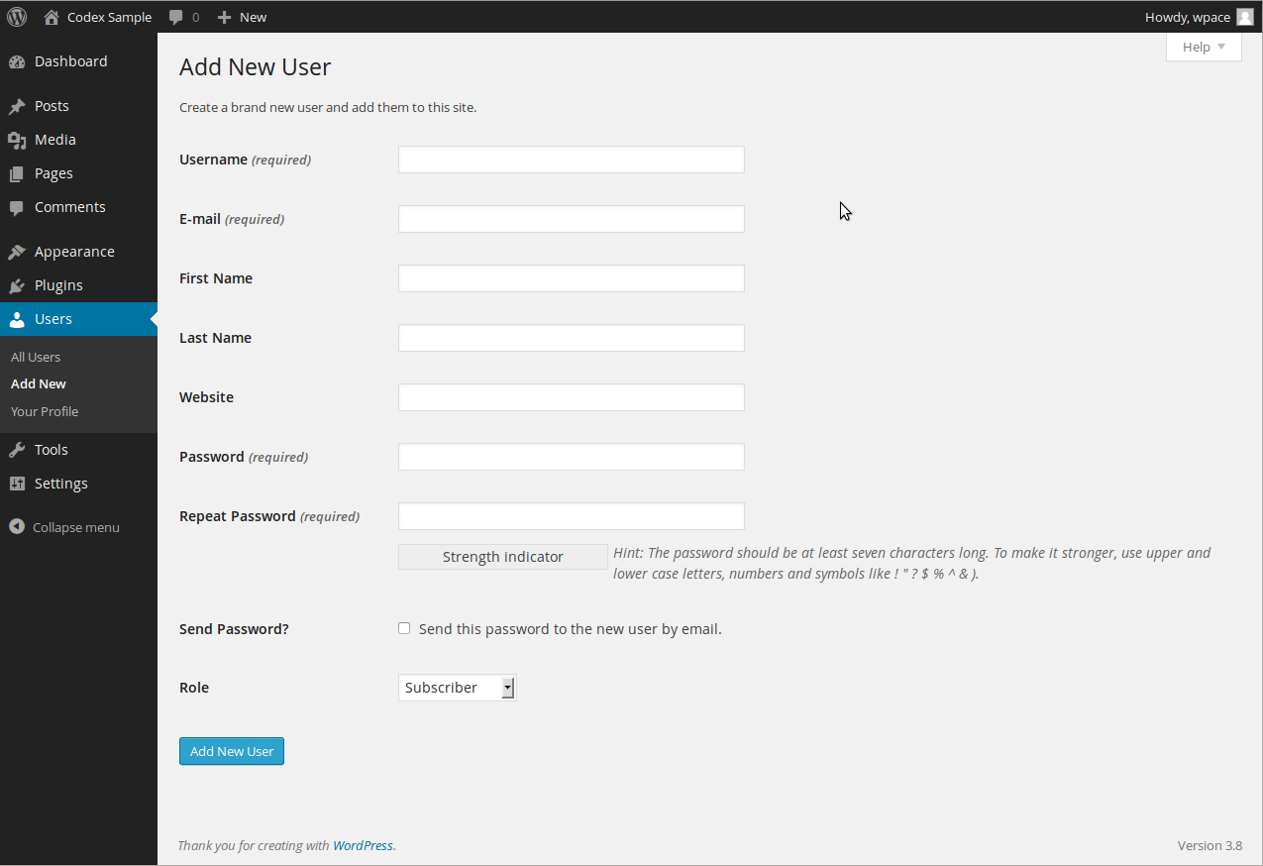

Fill out the appropriate information and set their role. “Editor” is often a good choice if you want them to have all capabilities other than administrative.
To view a list of each Role’s capabilities, please use the “Help” button on the user screen, or go to the following URL:
http://codex.wordpress.org/Roles_and_Capabilities

Check the box to Send Password if you’d like the user to receive an email with their password in it. Click “Add New User”.

USERS – USER MANAGEMENT

You may administer users by clicking “All Users” on the left.

Delete
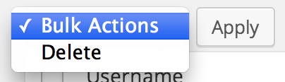
Check the select box beside any users you want to remove, and in the “Bulk Actions” drop down menu select “Delete”. Or hover over the username and click “Delete” from the options that appear.

Edit
To edit a specific user, hover your mouse pointer over the username and click “Edit” from the options that appear. Here you’ll see the same options that you have access to in your personal profile screen.

COMPANY INFORMATION

You have the ability to change the company phone number that displays at both the top and bottom of the site, as well as the address listed at the bottom of the website. You can also manage popular social media accounts that display in the footer.

To Change the Phone Number in the Header of the Site:
Move your mouse over “Divi” and click “Theme Customizer.” Click on “Header & Navigation” and then “Header Elements”. Here you will be able to edit the phone number displayed in the header of your website. Once you’ve edited it, click “Save & Publish” to save your changes.

Sometimes your phone number may be found within a menu instead. To edit a phone number related to the navigation, hover over “Appearance”, and click on “Menus”. Under “Select a menu to edit” select either the Main Menu or the Top Menu, depending on where your phone number is found and click “Select”. You may then click the arrow next to the phone number to edit the number and custom link. Click “Save Menu” to commit the change.

To Change the Address in the Footer of the Site:
Move your mouse over “Appearance” and click on “Widgets.” Usually your address is found under “Footer Area #1” (if on the left side of the page), so click that to make it expand. If you don’t see a “Text” block in here with your name, then check the other Footer Areas. Clicking the “Text” block should expand it to show the information contained in that area. You may simply type new information here to reflect any changes. Click “Save” at the bottom of the expanded “Text” block to save your edits.

If editing phone numbers and addresses, don’t forget to edit them on the contact page as well! Follow content editing guidelines to do so.

To Change Social Media Site Addresses:
Move your mouse over “Divi” and click on “Theme Options” in the dropdown that appears. On this page you can enable or disable the social media icons you’d like to display, and you can use the URL fields to enter the URL to your social media profiles. If you need to add, change or remove a social media profile that is not listed here, please contact us.
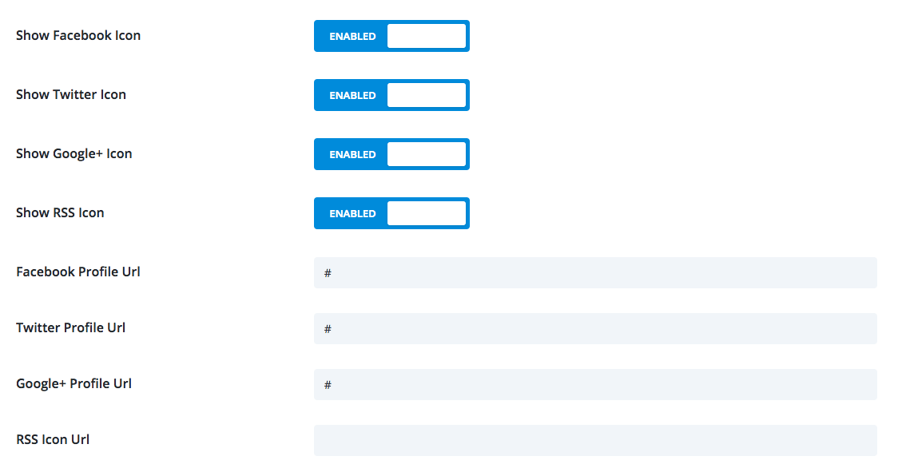

Scroll to the bottom and click “Save Changes” when you are done.

Don’t forget to update any of these things listed on your contact page!

FORM SETTINGS

Form submissions may be routed to multiple email addresses, and those email addresses can be edited at any time. In order to do this, click on “Forms” in the left hand navigation. Select the form that you would like to change the settings for. Roll over “Form Settings” and click on “Notifications”. Under this section, you can click on “Admin Notification”.

Send To
Here you can select whether you want to Enter Email – just simply enter an email into the field for Send to Email; Select a Field – use this if you want to send an email to the person who sent you the form; and Configure Routing – this setting would be used for sending to multiple email addresses, as well as routing to different people depending on selections made on the form.

The screen shot below shows an example of routing the form to different people based on form selection.
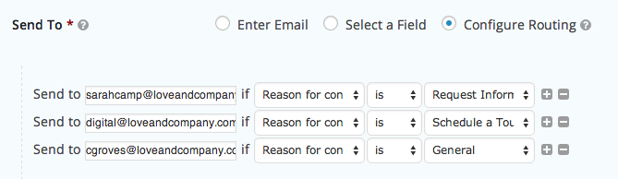

EDITING CONTENT - PAGES

There are two ways to access pages to edit them once you are logged into the WordPress system.

Perhaps the easiest way is to simply navigate to the live page in your browser. Once there, you’ll notice options at the top of the page. Click the “Enable Visual Builder” and this will take you into the visual editor.

Another way, if you are in the WordPress backend and/or if you’d like to do things such as delete a page, is to click on “Pages” on the left – this will bring you to the “Edit Pages” list. Here you will see a list of the editable pages on your web site.

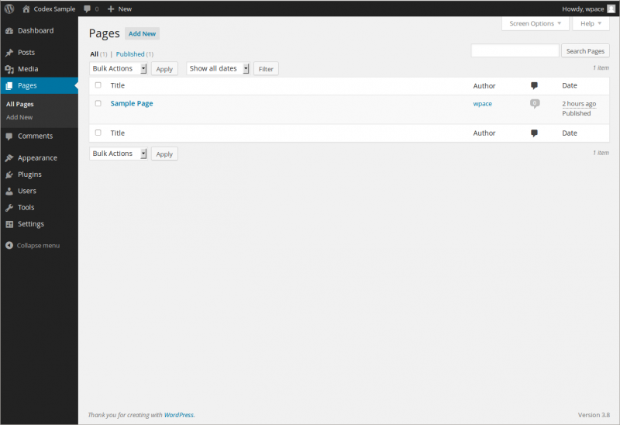

Pages will either appear in the order they are displayed on your site, or in alphabetical order. Sub-pages will be shown underneath their parent page with a hyphen before their name.

Hovering over a page title will bring up quick navigation. You will be given the choices “Edit”, “Quick Edit”, “Trash” and “View”. Read on for a more detailed overview of these options.
Edit
Click the page title, or click “Edit” in the quick navigation of the page you would like to edit. This will bring you to the Edit Page where you will be able to make changes to any content on that page.

We will discuss further information for items on this page in the Adding / Editing Content section.

Quick Edit
Click “Quick Edit” in the quick navigation under the page where you would like to quickly adjust the Title, Parent page, and Order. Click “Update Page” when you are finished, or click “Cancel” to close the Quick Edit.

Trash
Check the select box beside any pages you want to remove in the “Bulk Actions” drop down menu select “Move to Trash”. Or hover over the page title and click “Trash” from the options that appear. Before moving an item to the trash, please make sure it is not relied upon by any navigation, internal links, or site functionality.

Empty Trash
WordPress has a Trash feature similar to a trash bin or recycle bin on your computer desktop. This feature allows you to recover things that you may have mistakenly thrown away. However, you should keep the Trash empty or it could slow down your web site.

To empty the Trash, go to the “Pages” list. If you have pages in your Trash, you should see four options at the top of the list:

View
Clicking “View” will open the page within the web site so that you may view the page content within the context of the site design.

Add Page
To add a new page, click on “Add New” underneath the Pages menu on the left.

EDITING CONTENT – BLOG OR NEWS

Your site includes a Blog. You will be using your Posts menu to change both of these content types. Adding and editing posts works the same way as adding and editing pages (discussed in the following pages), save a few things. Note: To edit events, please see the additional Events tutorial.

When adding or editing a post, you always have the options to set it to any Categories and apply Tags to it.
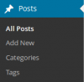
Categories
Within the blog, there are Categories, which are a helpful way to keep your blog entries organized. Think of categories like the table of contents of your blog. They make it easier to find information that the user is looking for. Click on “Categories” in the Posts menu to access the Categories page. This lists your categories, and you can add a new category directly from this page. Just like pages, you can make subcategories that have a parent category. You may organize this however you please. For posts you would like to have display on the News & Events page, set the post to the News category.

Try to limit your blog posts to only be in one to two categories.

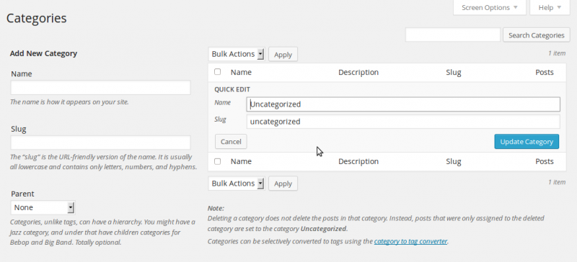

Tags
You may also want to utilize Tags. Tags make it much easier to search for content within your blog posts. If you think of categories like a table of content, tags represent the index of your blog. Tags are accessible by clicking on “Tags” from within the Posts menu. Limit the amount of tags on a post to the most important topics.

EDITING CONTENT – ADDING / EDITING – CLASSIC EDITOR / BLOG PAGES

By default, your website is set up to use the Classic WordPress editor. This is the editor that we suggest, as our clients find the new Block editor more difficult to use. If you would like to use the Block editor, you may change your settings to do so, and search the web for “How to Use WordPress Block Editor.”

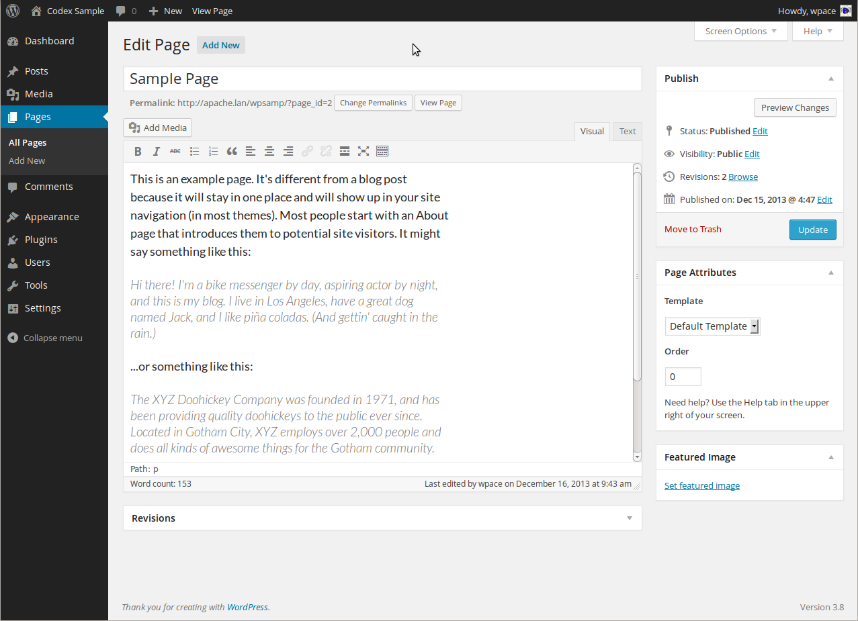

The first field is the Title. Here you will enter the text that will show up in your web site’s navigation or menu. Under this field, you will see the link that will show in the address bar of browsers.

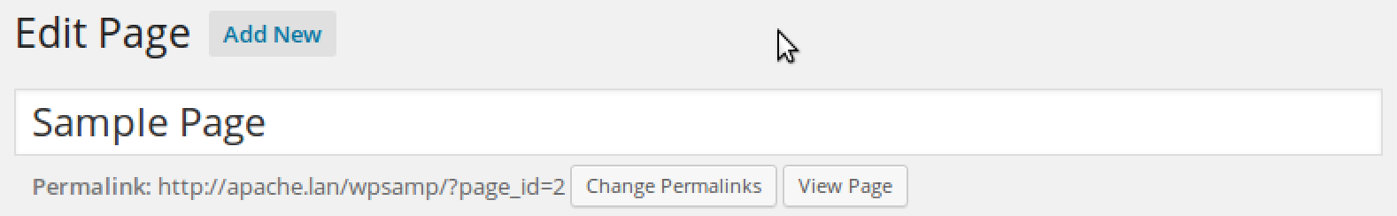

Next you will see a text area where you will be able to enter a body of content with your page. Above it will be buttons similar to those you would see in a publishing or writing program.

Make sure the tabs on the right are set to “Visual” so that you are not looking at the HTML coding. If you see a smattering of symbols that don’t make much sense (except to your computer), check your tabs!

Most of the styles that you select will adapt to your site’s style when you open the page in your web site. Within this editing page, though, it will look very plain.

Links
If you would like to create a link to another web site (or even an internal page on your site), highlight the desired text and click on the Insert / edit Link button. Enter the Link URL, if you would like the link to open in a new window, set the Target to Open link in a new window.

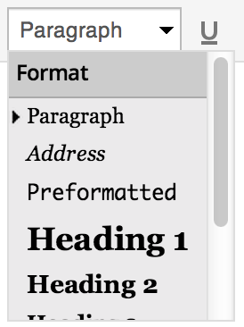
Format
Enter the content you would like to have on your web page. If you would like the page to have a heading, type it in and highlight it. In the “Format” drop down menu, select “Heading 1” – you may also select other heading styles for alternate types of headings.

If you don’t see the Paragraph option, click on the Kitchen Sink icon to expand your editing and format options.
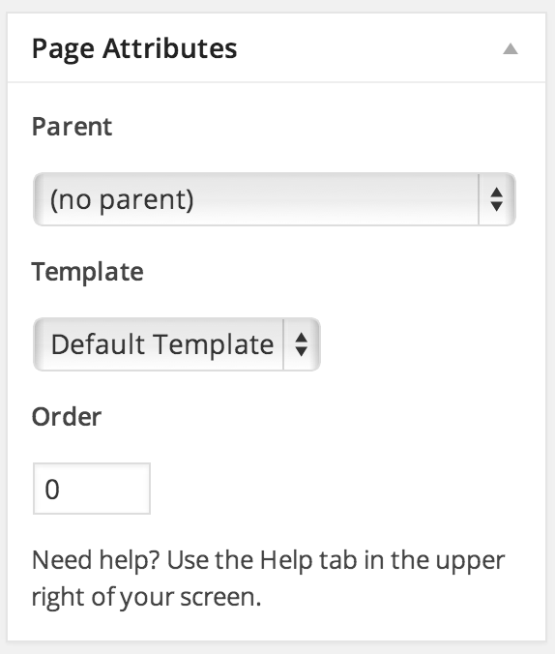

Attributes
If you would like this page to be a sub page of another page, select a parent page in the Attributes box.

You may also set a specific order for your pages to show, in relation to other pages in your site.

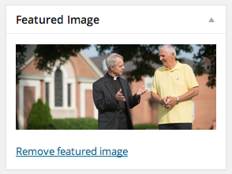
Header Image
If you would like to change the header image at the top of a particular page, you may do so by using the “Featured Image” content block. This works similarly to uploading media content, as explained later in this tutorial.

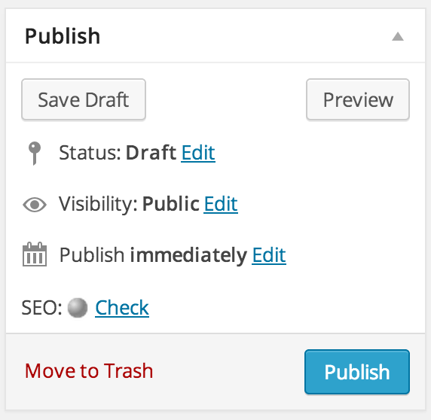
Saving and Publishing
If you’re not ready to publish your page, but you would like to save it to work on later, click “Save Draft”.

When you are finished, click on the “Publish” button. Your page is now visible on your web site.

EDITING CONTENT – UPLOAD FILES

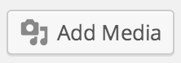
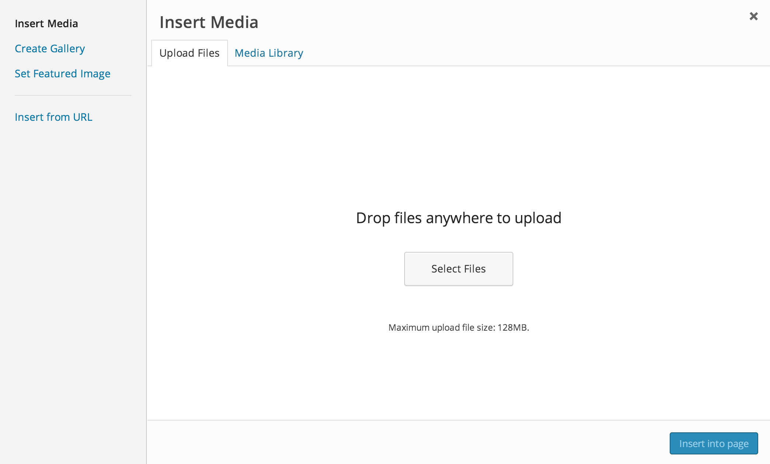
While editing a Page or a Post, you may upload and insert files using the Add Media tool.

Under the “Upload Files” tab, you can choose to either drag and drop files from your computer’s desktop or other folders in order to upload them, or you may click the button “Select Files” to browse to the files that you’d like to upload.
In WordPress 3.9+, you can drag and drop new files directly into your post window, which will automatically trigger the Add Media window.

You may also select the “Media Library” tab to browse and select files that you have already uploaded.

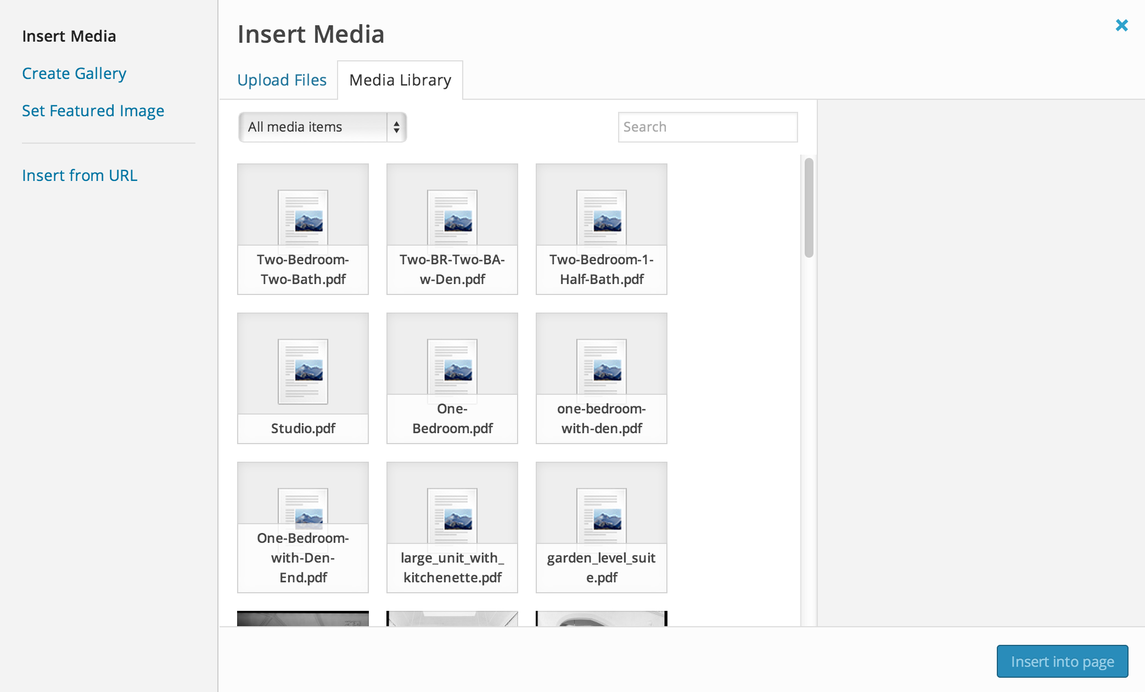

Accepted filetypes:

Images  - .jpg  - .jpeg  - .png  - .gif  Video  - .mp4, .m4v (MPEG-4)  - .mov (QuickTime)  - .wmv (Windows Media Player)  - .avi  - .mpg  - .ogv  - .3gp, .3g2 (3GPP, 3GPP2) | Documents  - .pdf (Adobe Acrobat)  - .doc, .docx (Microsoft Word)  - .ppt, pptx (PowerPoint Presentation)  - .odt (OpenDocument Text Document)  - .xls, .xlsx (Microsoft Excel)  Audio  - .mp3  - .m4a  - .ogg  - .wav

Not all web hosts permit these files to be uploaded. Also, they may not permit large file uploads. If you are having issues, please check with your host first.
WordPress has a built in capability to display video and other files from sources like YouTube by simply pasting the URL of the content onto its own line in your text. No need to mess with code! See more information about all of the content types supported here.

Insert Media Options
Once your file has uploaded, you will be directed to the Media Library tab, where you will see thumbnails of all of your media files displayed. The latest file that you have uploaded should be the first in the list, and should be selected – denoted by a checkmark in the upper right hand corner of the thumbnail.
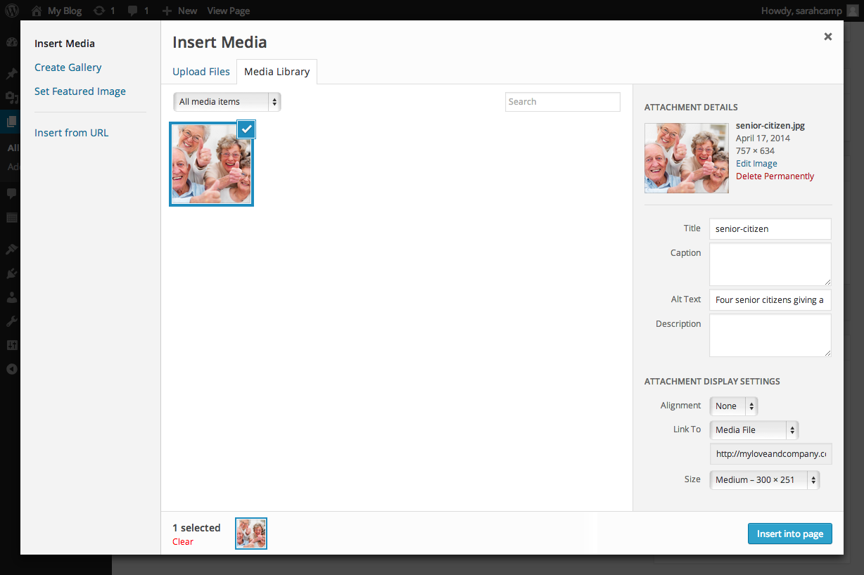

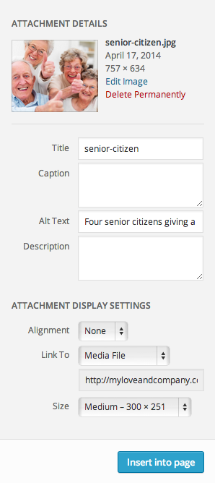
On the right hand side, you will see Attachment Details, which allows you to enter important meta information.

Title – Add a short description of the image, which will pop up after hovering over the image for a second. If you are adding a PDF, the Title will become the link (you can change this within the page editor). For the most part, the Title is more for back-end use.

Caption – This will appear below the image on your public facing web site, and should serve as a short description or reference.

Alt Text – This text is shown when an image can’t load (due to a loading error, text-only browser, etc.), and also used by screen readers to describe an image. Be very descriptive about the content of the image here. If your image includes any readable information, include that in the Alt Text. Always include Alt Text as the HTML will be invalid without them.

Description – A longer image description than the Caption, usually displayed when you use a thumbnail in a post or page to link to a larger image.

When you’ve completed the information to your satisfaction, click “Insert into page”.

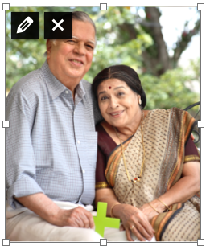
Within the post editor, click on the image to reveal resizing tools, as well as a pencil icon to access and change the Attachment Details as well as an X icon to remove the image from your page or post.

EDITING CONTENT – INSERT GALLERY

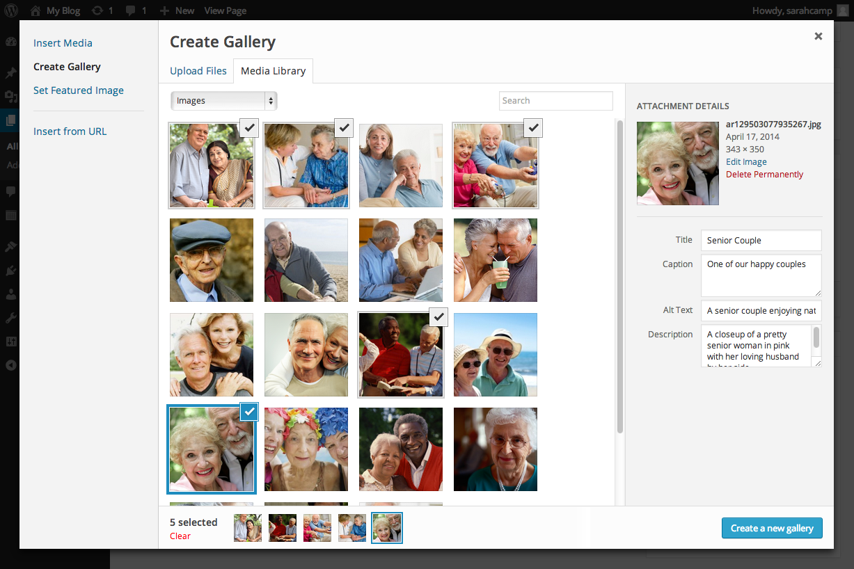
You can insert image galleries into your posts directly from the Add Media interface.

Click on thumbnails to select images for your gallery. The images you have selected will be denoted with a checkmark in the top right corner. You can also see how many you selected at the bottom, as well as small thumbnails of the selections. If you would like to deselect an image, click on it until the checkmark disappears.

When you’ve selected all of the images you desire, click “Create a new gallery”.
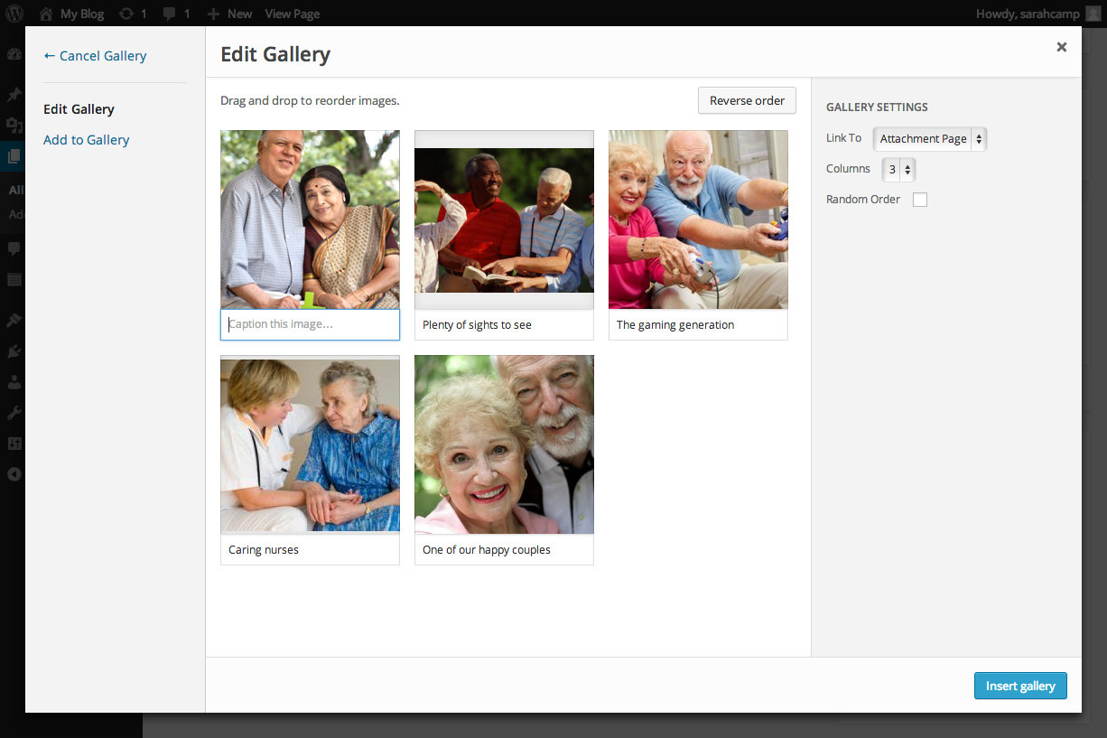

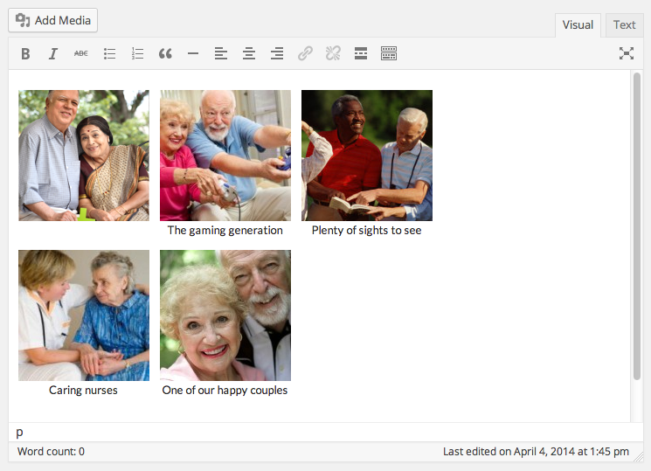
From the Edit Gallery window, you can drag and drop the image thumbnails to change the order in which they will appear. You can also click on images to set the Attachment Details as described in the previous section.

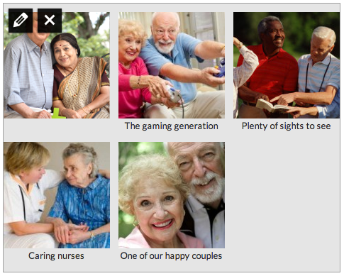
Click “Insert gallery” and you will be taken back to the page editor, where you will see a preview of the gallery in your page content.

Clicking on the gallery will bring up your editing tools. The pencil icon will take you back into the Edit Gallery window, where you can reorder images and change their Attachment Details. The X icon will remove the gallery from your page or post.

EDITING CONTENT – Page Builder

Love & Company is now building sites using an extremely powerful page building tool built upon the Divi framework. This system gives you the ability to do almost anything you like on any page.

STANDARD PAGE BUILDER
There are two ways to edit a page using the builder, one is the Page Builder, which shows up on the Page Editor once it is enabled. With the Builder enabled, your page editor will look similar to this:
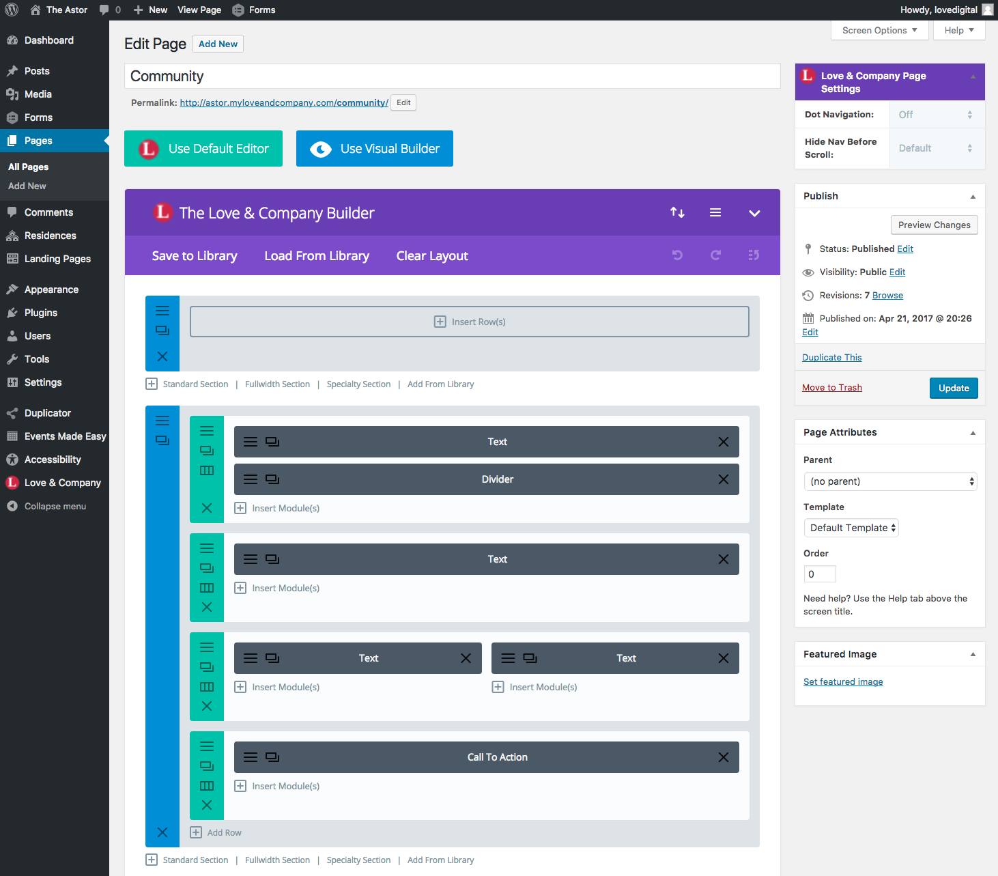

You can drag and drop these items anywhere by clicking and holding in the colored bar area. They can be deleted by clicking the X. And right-clicking the colored bar will bring up some more advanced options.

To simply edit one, you may click on the icon of the 3 lines, at the top or left of the colored bar. This will pull up content and any options available. The content editor is similar to the build-in WordPress editor, and has basically the same options. You can insert media as discussed with previous methods.

In addition, you will notice there is the ability to use columns. The green boxes are row containers. These can be configured to multiple column layouts. To do so, click on the icon that is a box split into 3 sections. Here you are given the column layout options. Note that in mobile, these will reduce down to single-column format, with the first column appearing first in your content, followed by the second, and so-on.

THE VISUAL BUILDER

The Visual Builder is very easy to use and will make updating your site a breeze. To use it, simply navigate to the page you’d like to update while logged in. At the top of the page should be a WordPress navigation bar. Click on “Enable Visual Builder”

Now the page becomes an editable page, right in your browser! You can edit the page and see exactly what it will look like in real time.

If you’d simply like to edit text, you can click directly where you’d like to edit it, and type. You may also bring up the module editors; when you roll over a module you will see a small bar with icons pop up. Click on the gear to access the editor for the module. Here, you can type into the standard editor, and you can change other options such as style.

You may also drag and drop modules to anywhere else on the page by using the crossed arrows icon, and click on the trash can to completely delete a module.

Please visit the Divi documentation for more information on how to use the Visual Builder:
https://www.elegantthemes.com/documentation/divi/visual-builder/

MODULES

You can add a new module by clicking “Insert Module” within the row box. You can see that there are many to choose from.
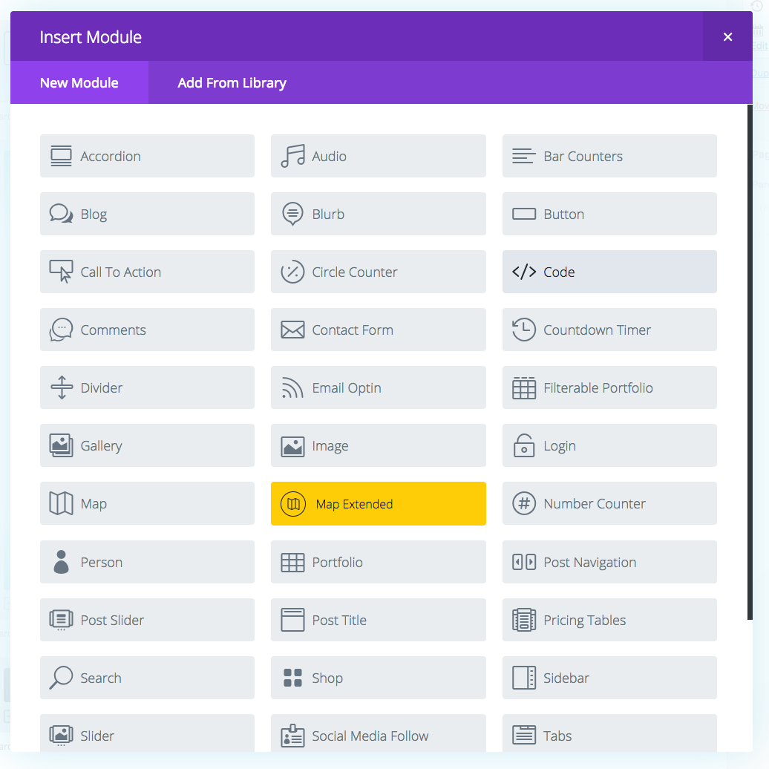

Modules MUST be contained within a Row, Rows must be contained within a Section. The only time where this may differ is in full-width sections, which do not have Rows, they only have a module within them. This is because they are made for specific functionality.

GLOBAL ITEMS

If a bar or section is showing up a bright lime green on your page, it means it is set up as a global item. This means that if you change it in one place, it will update across the entire site, for all instances. This is particularly helpful in reused content such as Calls to Action. Just make sure if you update one, that you mean to update all of them.

RESIDENCES AND LOCATION PAGES

If you have a multisite, we most likely will have taken advantage of our Locations component of the site. Other singular communities may utilize residences instead, to display residence-specific floor plans, images, and amenities.

If your site uses either of these, you’ll find these pages located in a separate section from “Pages” called Locations or Residences, respectively. Clicking on the name in the menu will bring you to the list of pages within that section, and you can edit the pages here just like other pages on the site that utilize the page builder and visual builder. Please see the video if you’d like more information on some of the special features included in these sections.

For more help on using specific modules, please visit the relative pages in Divi’s documentation:

Text module:
https://www.elegantthemes.com/documentation/divi/text/

Adding video to your page:
https://www.elegantthemes.com/documentation/divi/video/

Toggle / Accordion modules (FAQs, etc.)
https://www.elegantthemes.com/documentation/divi/toggle/
https://www.elegantthemes.com/documentation/divi/accordion/

Testimonials
https://www.elegantthemes.com/documentation/divi/testimonial/

Sliders:
https://www.elegantthemes.com/documentation/divi/slider/

Images:
https://www.elegantthemes.com/documentation/divi/image/

Gallery:
https://www.elegantthemes.com/documentation/divi/gallery/

Divider:
https://www.elegantthemes.com/documentation/divi/divider/

Button:
https://www.elegantthemes.com/documentation/divi/button/

Blurbs (w/ Icons):
https://www.elegantthemes.com/documentation/divi/blurb/

EDITING CONTENT – Yoast SEO

We install Yoast SEO on our sites to make it easier for users of all backgrounds to write better SEO copy on blog post pages. You’ll notice a Yoast SEO score in the top bar of your WordPress installation for each page you visit, even when you’re visiting it on the site, as long as you’re logged in. You’ll also notice a few quick SEO comments near the publish button on the edit page. If you scroll down under the content block, you’ll see a Yoast SEO block with some very powerful tools.

SNIPPET
If you’re unhappy with how your page shows up in Search Engine Results Page Listings, you can change this under Yoast SEO. Approach it like marketing copy – it doesn’t have a lot of bearing on where the entry falls in search results, but including likely keywords can be helpful to eliminate confusion, Google will also bold those keywords in your entry, and writing content that entices users to click on it is the most important part. Keep in mind that if Google finds more relevant content on your page to the user’s search, it will use that instead of your snippet.

FOCUS KEYWORD

Your focus keyword is the content subject you’ve written about in the post – what is the most important thing in the post that you’ve focused on that would give you the most benefit as a keyword to support? Once you’ve set that, Yoast SEO will be able to provide an analysis of the page with recommended changes to support your focus keyword and improve SEO. You don’t need to make all of the changes, but the more you can make, the better your page score will be.

SOCIAL SHARING

Yoast SEO also includes some great tools to refine how your content looks when shared to Social Media. If you click on the sharing tab icon, you can override the Title, Description, and image that shows when someone shares the post or page. Many times social media platforms will grab the first image and content they come to when they get to your page, which typically ends up being your logo (which will most likely be stretched or blown up), and administrative content. So setting this information can prove to be very beneficial.

