MANAGING EVENTS

Your web site is equipped with an Events Management System. This system allows you to add events to your site, including event information, registration, and allows you to manage attendees.

Updated January 19th, 2018

GETTING STARTED

Before we start, you must first login to your site’s administrative area. Please refer to the WordPress Tutorial for instructions.

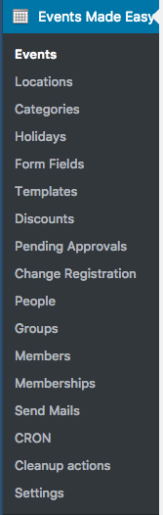
In the left sidebar menu, select “Events Made Easy” – this will take you to the listing of Events currently in the system.

Events – The list of events in the system.

Locations – You should not need to access this unless an event is taking place in a location other than your community, or if you need to change information about your community.

Categories – In some cases, Categories may be used to sort events into separate pages.

Holidays – Here you can make lists of holidays that your community recognizes. When these lists are selected on recurring events, an event will not be created if it falls on a holiday.

Discounts – If you would like to set up discount codes to offer a discount on events, you may do so here.

Pending Approvals – If you have set an event to require approval, registrants will appear here until you manually approve them.

Change Registration – If you need to cancel or change a registration, you may do so here.

People – A list of people who have responded to your events.

Send Mails – This tool will send an email to all registered attendees of an event. Use with caution.

Cleanup – You may use this to clean up your database and get rid of old events.

Settings – The only thing you will need this section for is most likely payment options

Form Fields, Templates, Groups, Members, Membership, CRON – You will not need to access these.

EVENT LIST

The first screen you will come to when selecting “Events” from the left menu is the Event List.

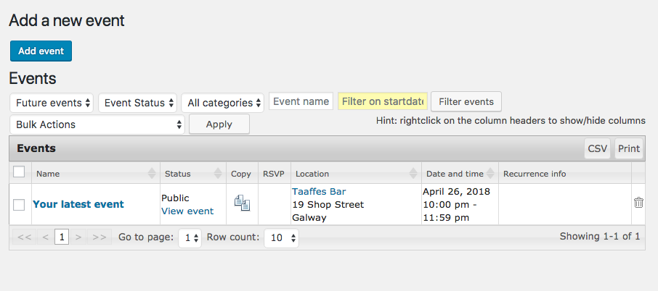

This shows you a listing of all of the events in your system. You can change which events are displaying, and also do a search for an event. You can click “View event” in the Status column to open the event in your public web site.

Clicking on an event’s name will take you to the edit page for that specific event.
Hint: You can click the “” symbol next to an event to save some time and create a duplication of that event.

ADD / EDIT EVENT

To create a new event, click “Add event” at the top of the Events list. Both the new event form and event edit form will be the same.

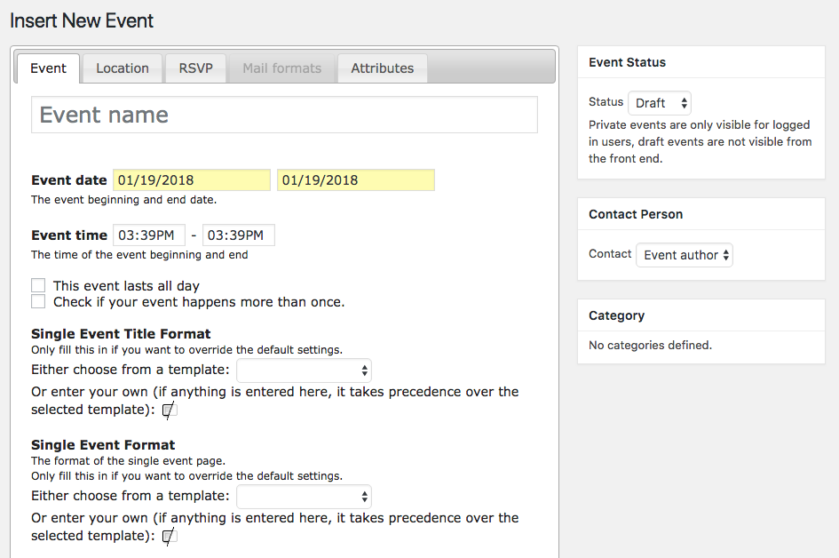

Let’s start with the fields on the left side. The event name will display in the list of events on the public site. The event start date and time will also display in the list.

For the end date, if the event lasts less than a day, make sure you select the same date as the beginning date. For recurring events, enter the date of the first occurrence. If the event lasts all day, select that check box. Otherwise, enter the beginning and end time under Event Time.

If this is a recurring event, select “Check if your event happens more than once.”
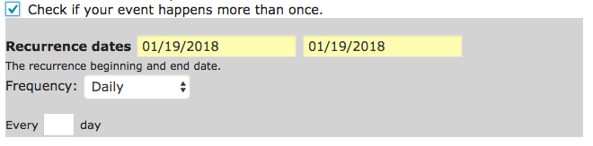
Here you may enter the beginning date that the event starts to happen, and the last day you’d like the recurrence to occur. The system will automatically add events to the calendar dependent upon what you enter under “Frequency.” If you’d like to add events to specific dates that are not pattern-dependent, you can select “Specific days” and then click in the Recurrence dates box to add all of the dates.
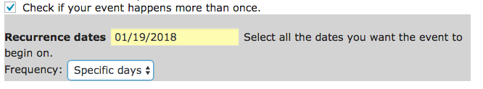

The next few “format” boxes you won’t need to worry about, as these are more advanced settings that override the defaults for this particular event.

Details – All of the supportive information for your event should be entered here. This will display on the single event page before an RSVP form (if applicable).
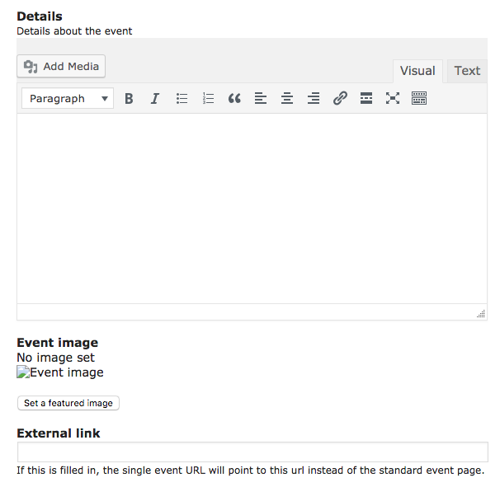

Event Image – Here you may upload a featured image, which will display in the list of events on your public events page. Add this to draw attention to your event and create excitement.

External Link – If you’d like to add an event to your system that is being hosted elsewhere, and you’d like to point directly to an external URL for event information/registration, you may do so by adding the link here. This will bypass any and all information on your own site. In the public-facing events list, the user will see the Event Name and dates, and the Event Name will link directly to the external site.

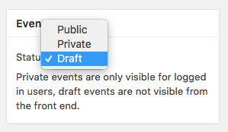
On the right side, Event Status should be set to Public when you want the event to display on the site. If an event is not displaying and is set to occur in the future, this will be the first setting you’ll want to check.

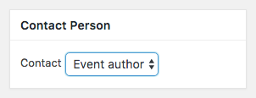
Contact Person will always default to the Event author, which is the person who created the event. The system will email the Contact Person when someone registers for the event. You can set this to any other user: the system will use the email address in the user’s profile.

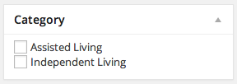
Category – Your site may be set up with multiple categories available for events in order to display a different list of events on different pages in the site. If this is the case, select the relevant category or page that the event will display on.

TOP TABS

At the top of the page, you’ll notice there are several “Tabs” available.

Location – You may enter information for the location, which will automatically generate a Google Map. If you start typing in your community name, it will automatically appear and you can select it to populate the address information. You may, instead, see a select menu here. If that is the case, you may select the location from the drop down list. If you do not see your location, you may type in your address to generate the map.
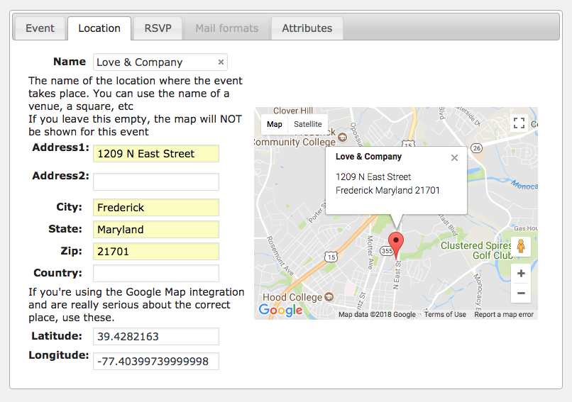

RSVP

If you would like to require users to register for an event, whether it is just to RSVP for a space, or to pay a registration fee, select “Enable registration for this event” under the RSVP tab.
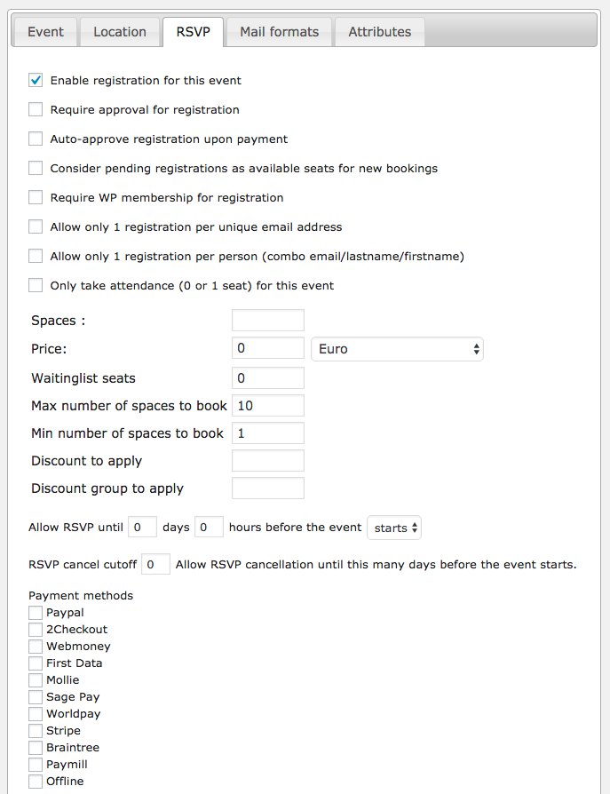
You may select whether you want to require approval for registration (manual), auto-approve registration when the registrant has paid in full, include pending registrations in the available seat count or not, and require WordPress membership for registration (in most cases you would want to leave this unchecked).

Spaces – Enter the amount of spaces available for this event. You may leave this blank if you don’t want to limit spaces. When the spaces have been filled through the online system, the registration form will not display. Note that the system will not account for offline registration, so keep that in mind!

Price – The cost of registration for one space.

Max/Min number of spaces to book – The maximum and minimum number of spaces a registrant is allowed to book at one time.

Discount to apply – You may select discounts that you’ve set up under “Discounts” to be able to apply on this event.

Allow RSVP until – Here you can set when the registration form will stop displaying on the site based on how long it is until the event starts. This would give you the ability to do an “RSVP by” date, or give you enough time to get an accurate count for an event, without worrying about someone else signing up at the last second.

Payment methods – In most cases, Paypal or Stripe will be the method to select here. If you are registered with another vendor and it is set up in the event settings area, you may select that vendor instead.

HOLIDAYS

Create a holidays list to set up days to be skipped when the system adds recurring events. Simply add a list name, and then list out the dates you’d like to skip, one per line.
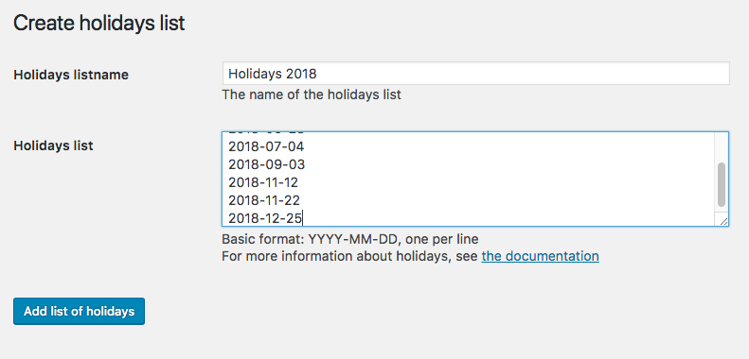

INSERT EVENT LISTING ON A PAGE

Use shortcodes to insert a listing of events on a specific page. Paste the following codes into the page content within WordPress.

To insert a listing of all events without filters:
[eme_events]

To insert a listing of events in a specific category:
[eme_events category=1]

Find the category number by clicking on “Categories” under Events. Use the number listed under the “ID” column next to the respective category.

To view more filter options:
http://www.e-dynamics.be/wordpress/?cat=18

Events Listing in Sidebar
You may also list events in a sidebar “widget.”

Navigate to “Widgets” under Appearance. Select the Primary sidebar area. Drag the “Events List” widget into the sidebar area. You may then set the options of the title you’d like to appear, number of events to display at a time, the category you would like to pull events from, and what pages to display it on (under Visibility).

